2027 華語課程招生簡章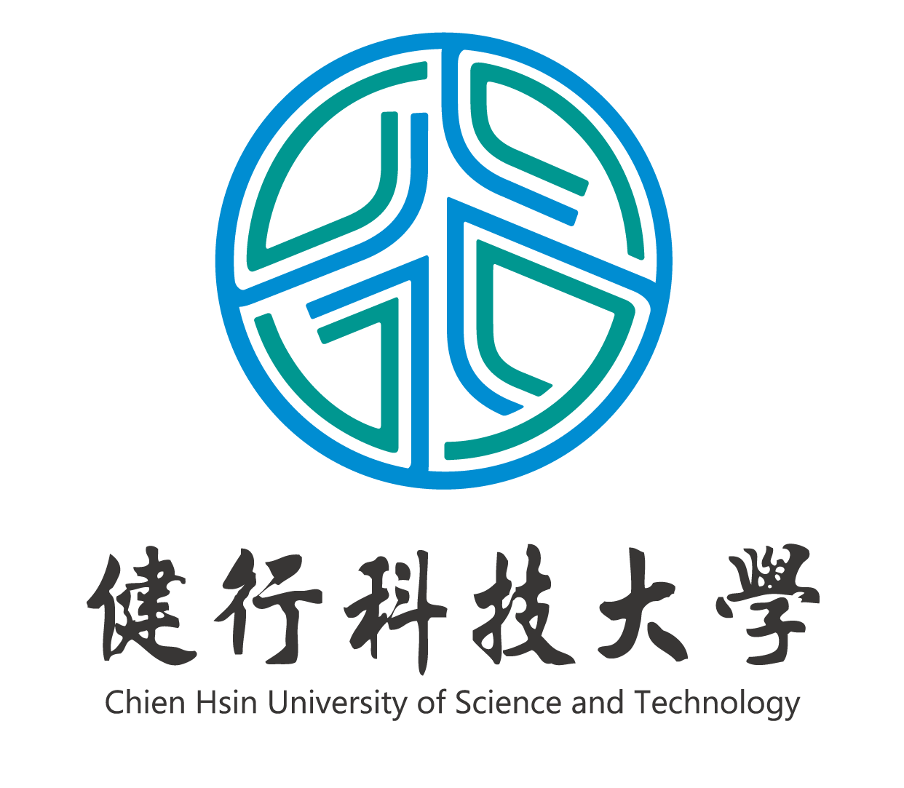

2027 Admission Brochure for Chinese Language Programs
華語 × 專業 × AI × 就業 | Mandarin × Profession × AI × Career

壹、中心簡介 About the Center
健行科技大學位於桃園市中壢區，鄰近桃園航空城與「亞洲・矽谷」計畫核心地帶，交通便捷、產業資源豐沛。華語文教學中心以「華語 × 專業 × AI × 就業」為定位，結合本校工程、商管、設計等系所優勢，為外籍學習者打造從華語學習、專業衜接到在臺就業的完整路徑。中心設有 TOCFL（華語文能力測驗）正式考場，學生可就地應試考照；並運用「華語文能力測驗快篩系統」精準分班，於 AI 專用電腦教室導入 AI 輔助個別化學習，讓每一位學生的進步都有數據可循。
Located in Zhongli, Taoyuan—at the heart of the Taoyuan Aerotropolis and the "Asia Silicon Valley" corridor—the Chinese Language Teaching Center of UCH builds a complete pathway from Mandarin learning to academic advancement and employment in Taiwan. The Center hosts an official on-campus TOCFL test site, uses a rapid placement system for precise class grouping, and provides AI-assisted personalized learning in a dedicated AI classroom, so every learner's progress is visible and measurable.

貳、六大特色 Six Key Features
1. 精緻小班、快篩分班：以快篩系統精準檢測程度，因材施教。
Small classes with data-driven placement for teaching tailored to each learner.
2. 校內 TOCFL 正式考場：學習與考照一站完成。
Official TOCFL test site on campus—learn and get certified in one place.
3. AI 輔助個別化學習：AI 專用電腦教室支援自主學習與診斷回饋。
AI-assisted personalized learning with diagnostic feedback in a dedicated AI classroom.
4. UCH 3T 專業華語：科技（Tech）、商務與管理（Trade & Business）、永續（Sustainability）三大主軸。
UCH 3T Specialized Mandarin: Tech, Trade & Business, and Sustainability tracks.
5. 產學鏈結：企業參訪、業師講座與實習機會，課堂所學與產業實踐合一。
Industry links: company visits, guest lectures and internship opportunities.
6. 文化體驗與在地融入：主題文化活動與生活輔導，快速適應在臺生活。
Cultural immersion and student-life support for a smooth landing in Taiwan.

參、課程總覽 Program Overview
課程 Program | 班級人數 Class Size | 時數 Duration | 學費 Tuition (NTD)
短期課程 Short-term Programs
TOCFL 證照班  TOCFL Preparation Course | 個人班 1–3 人／  精緻小班 4–15 人 | 每期 8 週，共 16 小時  8 wks / 16 hrs | 校內外籍生免費；校外：個人班 5,000／小班 3,500  Free for UCH students
實用華語基礎與客製化專班  Practical & Customized Mandarin | 1–2 人  （企業可另組班） | 每期 10 週，共 30 小時  10 wks / 30 hrs | 15,000／人（企業及移工專班另議）
海外青年華語營  Mandarin Camp | 團體成班 | 寒暑期短期密集  Intensive, by project | 依各梯次簡章公告  See camp brochure
長期課程 Long-term Programs
季制華語正規班  Regular Seasonal Program | 5–15 人 | 每期 11 週，共 165 小時  11 wks / 165 hrs per term | 25,000／期
商務與職場華語專班  Mandarin for the Workplace | 3–10 人 | 每期 11 週，共 165 小時  11 wks / 165 hrs per term | 30,000／期
學位衜接華語先修班  University Preparatory Program | 10–18 人 | 兩學期，全年 720 小時  720 hrs / year | 50,000／年
健行 UCH-PATH 產業華語季制課程 | 10–15 人 | 每期 11 週，共 165 小時  11 wks / 165 hrs per term | 25,000／期
※ 報名費 NTD 500／人；學費不含保險、書籍及教材費。所有學員開課前均須參加華語文能力快篩測驗，依程度編班。
Registration fee: NTD 500. Insurance, books and materials are not included. All students take a placement test before classes begin.

肆、課程介紹 Course Descriptions

一、TOCFL 證照班 TOCFL Preparation Course
專為考取「華語文能力測驗（TOCFL）」設計，聚焦應試技巧、題型解析、模擬測驗與答題策略；本校設有 TOCFL 正式考場，可就地應試。上課時間：週一至週五 09:00–17:00 之間彈性安排。
Designed for learners aiming to pass the TOCFL, focusing on test-taking strategies, question analysis and mock exams. Students may take the official test right on campus. Flexible scheduling, Mon.–Fri. 09:00–17:00.

二、實用華語基礎與客製化專班 Practical & Customized Mandarin
依學員程度與需求彈性客製，涵蓋日常溝通與基礎華語；並結合產學合作推動「企業外籍員工華語培訓」，提供零起點至流利級之客製課程。教材：《當代中文課程》或依需求編選。
Flexible, tailor-made courses covering daily communication and foundational Mandarin, including corporate training programs for foreign employees—from absolute beginner to fluent levels.

三、海外青年華語營 Mandarin Camp
短期密集華語結合文化體驗，規劃「廚藝」、「商務」與「STEAM」三大主題營隊，著重專業實作與在地文化融入。
Short-term intensive Mandarin plus cultural immersion, with Culinary, Business and STEAM themed camps emphasizing hands-on learning.

四、季制華語正規班 Regular Seasonal Program
標準學季制課程，全學程共九級，入學依分級考試編班；並與海外姊妹校合作，輔導學生通過 TOCFL A2 檢定以衜接本校學位課程。上課時間：週一至週五 09:00–12:00 或 13:00–16:00。教材：《當代中文課程》。
A standard nine-level seasonal program with placement testing. In partnership with overseas sister schools, the Center coaches students to pass TOCFL A2 for admission to UCH degree programs. Mon.–Fri., 09:00–12:00 or 13:00–16:00.

五、商務與職場華語專班 Mandarin for the Workplace
適合 B2（含）以上程度、規劃在臺工作或已在臺發展之外籍人士。聚焦職場實務語言、商務交流、行銷簡報與客訴處理，並協助安排企業參訪與實習。教材：《各行各業說中文》。
For learners at B2 or above planning to work in Taiwan. Focuses on workplace language, business communication, presentations and customer relations, with company visits and internship arrangements.

六、學位衜接華語先修班 University Preparatory Program
為計畫進入臺灣大專院校就讀者設計之高強度密集課程（每週 20 小時），全方位衜接大學學術語文需求，開課前以快篩系統精準分班。
A high-intensity program (20 hrs/week) preparing international students for the academic language demands of degree study in Taiwan.

七、健行 UCH-PATH 產業華語季制課程
呼應國家產業政策與桃園產業聚落特色，採「一般華語＋專業華語＋產業參訪」三位一體模式：A1 校園與生活華語 → A1–A2 科技華語（AI／半導體／ICT）→ A2–B1 商務與管理華語 → B1 以上永續華語（ESG／綠能／SDGs），培育兼具華語能力與專業知能之國際人才。
Aligned with Taiwan's industrial policy and Taoyuan's industry clusters, the 3T program integrates general Mandarin, specialized Mandarin and industry visits across four stages: Campus Life (A1), Tech Mandarin (A1–A2), Trade & Business Mandarin (A2–B1), and Sustainability Mandarin (B1+).

伍、級別架構與 TOCFL 對照 Levels & TOCFL Benchmarks
級別 Level | CEFR／TOCFL | 學習目標 Learning Goals
初級 1–2 級  Beginner | A1–A2 | 自零起點開始，著重發音、基礎漢字與日常生活用語。  Pronunciation, basic characters and daily-life expressions.
中級 3–6 級  Intermediate | B1–B2 | 擴展至社交與職場應用，能閱讀長句並流暢表達。  Social and workplace usage; fluent expression and extended reading.
高級 7–9 級  Advanced | C1–C2 | 朝專業領域深化，能理解與討論報章雜誌及文學作品。  Professional-level discussion of media and literature.

陸、開課時間與申請方式 Terms & Application
開課時間：長期課程全年 4 期，每年 3、6、9、12 月開課，每期 11 週（不含國定假日）。
Terms: Four terms per year, starting in March, June, September and December; 11 weeks per term (national holidays excluded).
申請期限：境外申請人請於開課前 2 個月、在臺申請人請於開課前 1 個月完成報名。
Deadlines: Overseas applicants—2 months before the term begins; applicants in Taiwan—1 month before.

申請流程 Application Procedure
1. 填寫報名表並繳交文件 Submit the application form and documents（報名網址 Online form： ）
2. 資料審核 Document review
3. 寄發入學通知書及繳費資訊 Admission letter and payment information issued
4. 憑入學通知書辦理來臺簽證 Apply for a visa with the admission letter
5. 至中心報到、繳費並參加快篩分班測驗 Register, pay tuition and take the placement test

應繳文件（新生） Required Documents (New Students)
護照影本 Passport copy｜最高學歷證明影本 Diploma copy｜財力證明（3 個月內、美金 2,500 元以上）Financial statement (issued within 3 months, min. US$2,500)｜半身照片 2 張 Two passport-size photos｜有效保險證明 Proof of valid insurance。舊生檢附簽證或居留證影本及保險證明。Returning students: visa/ARC copy and proof of insurance.
※ 退費依本校規定及教育部相關法令辦理；課程因人數不足未開班者，已繳費用全額退還。結業：缺課未逾總時數三分之一且考試及格者，核發結業證書。
Refunds follow university and MOE regulations; full refund if a class is cancelled. A certificate of completion is issued to students with attendance above two-thirds who pass the final assessment.

柒、聯絡我們 Contact Us
地址 Address：320678 桃園市中壢區健行路 229 號 健行科技大學 華語文教學中心
Chinese Language Teaching Center, Chien Hsin University of Science and Technology, No. 229, Jianxing Rd., Zhongli Dist., Taoyuan City 320678, Taiwan (R.O.C.)
電話 Tel：03-4581196 # 6201 Email：ico@uch.edu.tw
報名系統: https://fpo.uch.edu.tw/p/404-1015-2717.php?Lang=zh-tw 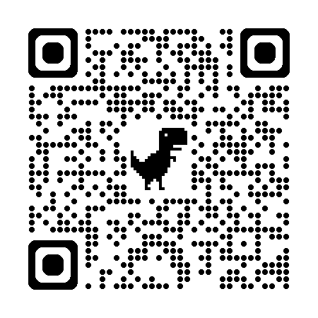

誠摯邀請您加入健行，讓我們幫您實現華語夢！
Join UCH and let us help you achieve your Mandarin dream!

